**影像元件練習**

1. 請參考投影片內容，建立以下的Android應用程式

(為了看第二題的動態效果，最好另存為html檔才能觀看)

並請將1.**建立過程**; 2.程式**執行結果**截圖; 2.程式**原始檔 copy&paste**置入作業中

1. 請參考投影片的猜拳遊戲範例，設計另一遊戲程式 – 數字比大小

* 1. 使用者由數字1~6中選一數字，使用ImageButton顯示數字供使用者點選
  2. 電腦亂數1~6，使用ImageView顯示數字
  3. 比對結果，輸出輸贏結果

還沒按下之前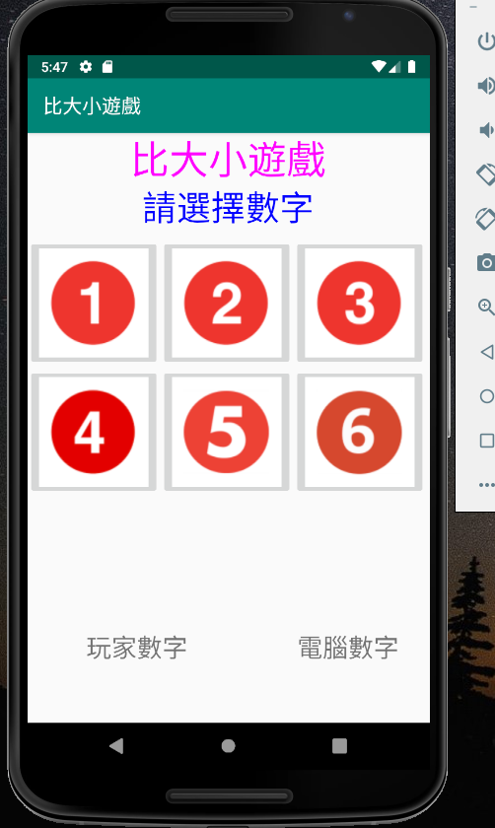

* 1. 並請設計良好的使用者介面

MainActivity.java

**package** com.app.game;  
  
**import** android.support.v7.app.AppCompatActivity;  
**import** android.os.Bundle;  
**import** android.view.View;  
**import** android.widget.Button;  
**import** android.widget.ImageButton;  
**import** android.widget.ImageView;  
**import** android.widget.TextView;  
  
**public class** MainActivity **extends** AppCompatActivity {  
  
 **private** TextView **mTxtResult**,**mTxV_S**;  
 **private int checknum**;  
 **private** ImageButton **mImgBtnnum01**, **mImgBtnnum02**, **mImgBtnnum03**, **mImgBtnnum04**, **mImgBtnnum05**, **mImgBtnnum06**;  
 **private** ImageView **mImgViewCom**,**mImgViewPLAY**;  
  
 @Override  
 **protected void** onCreate(Bundle savedInstanceState) {  
 **super**.onCreate(savedInstanceState);  
 setContentView(R.layout.***activity_main***);  
 **mTxV_S** = findViewById(R.id.***V_S***);  
 **mImgViewPLAY** = findViewById(R.id.***imgViewPLAY***);  
 **mImgViewCom** = findViewById(R.id.***imgViewCom***);  
 **mTxtResult** = findViewById(R.id.***txtResult***);  
 **mImgBtnnum01** = findViewById(R.id.***imgBtn_num1***);  
 **mImgBtnnum02** = findViewById(R.id.***imgBtn_num2***);  
 **mImgBtnnum03** = findViewById(R.id.***imgBtn_num3***);  
 **mImgBtnnum04** = findViewById(R.id.***imgBtn_num4***);  
 **mImgBtnnum05** = findViewById(R.id.***imgBtn_num5***);  
 **mImgBtnnum06** = findViewById(R.id.***imgBtn_num6***);  
  
  
 **mImgBtnnum01**.setOnClickListener(**imgBtnNUM01OnClick**);  
 **mImgBtnnum02**.setOnClickListener(**imgBtnNUM02OnClick**);  
 **mImgBtnnum03**.setOnClickListener(**imgBtnNUM03OnClick**);  
 **mImgBtnnum04**.setOnClickListener(**imgBtnNUM04OnClick**);  
 **mImgBtnnum05**.setOnClickListener(**imgBtnNUM05OnClick**);  
 **mImgBtnnum06**.setOnClickListener(**imgBtnNUM06OnClick**);  
 }  
  
 **private** View.OnClickListener **imgBtnNUM01OnClick** = **new** View.OnClickListener() {  
 @Override  
 **public void** onClick(View view) {  
  
 **int** iComPlay = (**int**) (Math.*random*() * 6 + 1);  
 **checknum** = 1;  
 **mTxV_S**.setText(getString(R.string.***V_S***));  
 **if** (iComPlay == **checknum**) {  
 **mImgViewPLAY**.setImageResource(R.drawable.***num_1***);  
 **mTxtResult**.setText(getString(R.string.***draw***));  
 } **else if** (iComPlay > **checknum**) {  
 **mImgViewPLAY**.setImageResource(R.drawable.***num_1***);  
 **mTxtResult**.setText(getString(R.string.***lose***));  
 } **else** {  
 **mImgViewPLAY**.setImageResource(R.drawable.***num_1***);  
 **mTxtResult**.setText(getString(R.string.***win***));  
 }  
 **switch**(iComPlay) {  
 **case** 1:  
 **mImgViewCom**.setImageResource(R.drawable.***num_1***);;  
 **break**;  
 **case** 2:  
 **mImgViewCom**.setImageResource(R.drawable.***num_2***);;  
 **break**;  
 **case** 3:  
 **mImgViewCom**.setImageResource(R.drawable.***num_3***);;  
 **break**;  
 **case** 4:  
 **mImgViewCom**.setImageResource(R.drawable.***num_4***);;  
 **break**;  
 **case** 5:  
 **mImgViewCom**.setImageResource(R.drawable.***num_5***);;  
 **break**;  
 **case** 6:  
 **mImgViewCom**.setImageResource(R.drawable.***num_6***);;  
 **break**;  
 **default**:  
 }  
 }  
 };  
  
 **private** View.OnClickListener **imgBtnNUM02OnClick** = **new** View.OnClickListener() {  
 @Override  
 **public void** onClick(View view) {  
  
 **int** iComPlay = (**int**) (Math.*random*() * 6 + 1);  
 **checknum** = 2;  
 **mTxV_S**.setText(getString(R.string.***V_S***));;  
 **if** (iComPlay == **checknum**) {  
 **mImgViewPLAY**.setImageResource(R.drawable.***num_2***);  
 **mTxtResult**.setText(getString(R.string.***draw***));  
 } **else if** (iComPlay > **checknum**) {  
 **mImgViewPLAY**.setImageResource(R.drawable.***num_2***);  
 **mTxtResult**.setText(getString(R.string.***lose***));  
 } **else** {  
 **mImgViewPLAY**.setImageResource(R.drawable.***num_2***);  
 **mTxtResult**.setText(getString(R.string.***win***));  
 }  
 **switch**(iComPlay) {  
 **case** 1:  
 **mImgViewCom**.setImageResource(R.drawable.***num_1***);;  
 **break**;  
 **case** 2:  
 **mImgViewCom**.setImageResource(R.drawable.***num_2***);;  
 **break**;  
 **case** 3:  
 **mImgViewCom**.setImageResource(R.drawable.***num_3***);;  
 **break**;  
 **case** 4:  
 **mImgViewCom**.setImageResource(R.drawable.***num_4***);;  
 **break**;  
 **case** 5:  
 **mImgViewCom**.setImageResource(R.drawable.***num_5***);;  
 **break**;  
 **case** 6:  
 **mImgViewCom**.setImageResource(R.drawable.***num_6***);;  
 **break**;  
 **default**:  
 }  
 }  
 };  
  
 **private** View.OnClickListener **imgBtnNUM03OnClick** = **new** View.OnClickListener() {  
 @Override  
 **public void** onClick(View view) {  
  
 **int** iComPlay = (**int**) (Math.*random*() * 6 + 1);  
 **checknum** = 3;  
 **mTxV_S**.setText(getString(R.string.***V_S***));  
 **if** (iComPlay == **checknum**) {  
 **mImgViewPLAY**.setImageResource(R.drawable.***num_3***);  
 **mTxtResult**.setText(getString(R.string.***draw***));  
 } **else if** (iComPlay > **checknum**) {  
 **mImgViewPLAY**.setImageResource(R.drawable.***num_3***);  
 **mTxtResult**.setText(getString(R.string.***lose***));  
 } **else** {  
 **mImgViewPLAY**.setImageResource(R.drawable.***num_3***);  
 **mTxtResult**.setText(getString(R.string.***win***));  
 }  
 **switch**(iComPlay) {  
 **case** 1:  
 **mImgViewCom**.setImageResource(R.drawable.***num_1***);;  
 **break**;  
 **case** 2:  
 **mImgViewCom**.setImageResource(R.drawable.***num_2***);;  
 **break**;  
 **case** 3:  
 **mImgViewCom**.setImageResource(R.drawable.***num_3***);;  
 **break**;  
 **case** 4:  
 **mImgViewCom**.setImageResource(R.drawable.***num_4***);;  
 **break**;  
 **case** 5:  
 **mImgViewCom**.setImageResource(R.drawable.***num_5***);;  
 **break**;  
 **case** 6:  
 **mImgViewCom**.setImageResource(R.drawable.***num_6***);;  
 **break**;  
 **default**:  
 }  
 }  
 };  
 **private** View.OnClickListener **imgBtnNUM04OnClick** = **new** View.OnClickListener() {  
 @Override  
 **public void** onClick(View view) {  
  
 **int** iComPlay = (**int**) (Math.*random*() * 6 + 1);  
 **checknum** = 4;  
 **mTxV_S**.setText(getString(R.string.***V_S***));  
 **if** (iComPlay == **checknum**) {  
 **mImgViewPLAY**.setImageResource(R.drawable.***num_4***);  
 **mTxtResult**.setText(getString(R.string.***draw***));  
 } **else if** (iComPlay > **checknum**) {  
 **mImgViewPLAY**.setImageResource(R.drawable.***num_4***);  
 **mTxtResult**.setText(getString(R.string.***lose***));  
 } **else** {  
 **mImgViewPLAY**.setImageResource(R.drawable.***num_4***);  
 **mTxtResult**.setText(getString(R.string.***win***));  
 }  
 **switch**(iComPlay) {  
 **case** 1:  
 **mImgViewCom**.setImageResource(R.drawable.***num_1***);;  
 **break**;  
 **case** 2:  
 **mImgViewCom**.setImageResource(R.drawable.***num_2***);;  
 **break**;  
 **case** 3:  
 **mImgViewCom**.setImageResource(R.drawable.***num_3***);;  
 **break**;  
 **case** 4:  
 **mImgViewCom**.setImageResource(R.drawable.***num_4***);;  
 **break**;  
 **case** 5:  
 **mImgViewCom**.setImageResource(R.drawable.***num_5***);;  
 **break**;  
 **case** 6:  
 **mImgViewCom**.setImageResource(R.drawable.***num_6***);;  
 **break**;  
 **default**:  
 }  
 }  
 };  
  
 **private** View.OnClickListener **imgBtnNUM05OnClick** = **new** View.OnClickListener() {  
 @Override  
 **public void** onClick(View view) {  
  
 **int** iComPlay = (**int**) (Math.*random*() * 6 + 1);  
 **checknum** = 5;  
 **mTxV_S**.setText(getString(R.string.***V_S***));  
 **if** (iComPlay == **checknum**) {  
 **mImgViewPLAY**.setImageResource(R.drawable.***num_5***);  
 **mTxtResult**.setText(getString(R.string.***draw***));  
 } **else if** (iComPlay > **checknum**) {  
 **mImgViewPLAY**.setImageResource(R.drawable.***num_5***);  
 **mTxtResult**.setText(getString(R.string.***lose***));  
 } **else** {  
 **mImgViewPLAY**.setImageResource(R.drawable.***num_5***);  
 **mTxtResult**.setText(getString(R.string.***win***));  
 }  
 **switch**(iComPlay) {  
 **case** 1:  
 **mImgViewCom**.setImageResource(R.drawable.***num_1***);;  
 **break**;  
 **case** 2:  
 **mImgViewCom**.setImageResource(R.drawable.***num_2***);;  
 **break**;  
 **case** 3:  
 **mImgViewCom**.setImageResource(R.drawable.***num_3***);;  
 **break**;  
 **case** 4:  
 **mImgViewCom**.setImageResource(R.drawable.***num_4***);;  
 **break**;  
 **case** 5:  
 **mImgViewCom**.setImageResource(R.drawable.***num_5***);;  
 **break**;  
 **case** 6:  
 **mImgViewCom**.setImageResource(R.drawable.***num_6***);;  
 **break**;  
 **default**:  
 }  
 }  
 };  
 **private** View.OnClickListener **imgBtnNUM06OnClick** = **new** View.OnClickListener() {  
 @Override  
 **public void** onClick(View view) {  
  
 **int** iComPlay = (**int**) (Math.*random*() * 6 + 1);  
 **checknum** = 6;  
 **mTxV_S**.setText(getString(R.string.***V_S***));  
 **if** (iComPlay == **checknum**) {  
 **mImgViewPLAY**.setImageResource(R.drawable.***num_6***);  
 **mTxtResult**.setText(getString(R.string.***draw***));  
 } **else if** (iComPlay > **checknum**) {  
 **mImgViewPLAY**.setImageResource(R.drawable.***num_6***);  
 **mTxtResult**.setText(getString(R.string.***lose***));  
 } **else** {  
 **mImgViewPLAY**.setImageResource(R.drawable.***num_6***);  
 **mTxtResult**.setText(getString(R.string.***win***));  
 }  
 **switch**(iComPlay) {  
 **case** 1:  
 **mImgViewCom**.setImageResource(R.drawable.***num_1***);;  
 **break**;  
 **case** 2:  
 **mImgViewCom**.setImageResource(R.drawable.***num_2***);;  
 **break**;  
 **case** 3:  
 **mImgViewCom**.setImageResource(R.drawable.***num_3***);;  
 **break**;  
 **case** 4:  
 **mImgViewCom**.setImageResource(R.drawable.***num_4***);;  
 **break**;  
 **case** 5:  
 **mImgViewCom**.setImageResource(R.drawable.***num_5***);;  
 **break**;  
 **case** 6:  
 **mImgViewCom**.setImageResource(R.drawable.***num_6***);;  
 **break**;  
 **default**:  
 }  
 }  
 };  
  
}

strings.xml

<**resources**>  
 <**string name="app_name"**>比大小遊戲</**string**>  
 <**string name="player"**>玩家數字</**string**>  
 <**string name="computer"**>電腦數字</**string**>  
 <**string name="V_S"**>V.S.</**string**>  
 <**string name="please_choose"**>請選擇數字</**string**>  
 <**string name="num_1"**>數字一</**string**>  
 <**string name="num_2"**>數字二</**string**>  
 <**string name="num_3"**>數字三</**string**>  
 <**string name="num_4"**>數字四</**string**>  
 <**string name="num_5"**>數字五</**string**>  
 <**string name="num_6"**>數字六</**string**>  
 <**string name="win"**>恭喜，你贏了！</**string**>  
 <**string name="lose"**>很可惜，你輸了！</**string**>  
 <**string name="draw"**>平手！</**string**>  
</**resources**>

Activity_main.xml

*<?***xml version="1.0" encoding="utf-8"***?>*<**android.support.constraint.ConstraintLayout xmlns:android="http://schemas.android.com/apk/res/android"  
 xmlns:app="http://schemas.android.com/apk/res-auto"  
 xmlns:tools="http://schemas.android.com/tools"  
 android:layout_width="match_parent"  
 android:layout_height="match_parent"  
 tools:context=".MainActivity"  
 tools:layout_editor_absoluteX="-4dp"  
 tools:layout_editor_absoluteY="120dp"**>  
  
 <**TextView  
 android:id="@+id/textView2"  
 android:layout_width="wrap_content"  
 android:layout_height="wrap_content"  
 android:text="@string/app_name"  
 android:textColor="#ffff00ff"  
 android:textSize="40sp"  
 app:layout_constraintBottom_toTopOf="@+id/txvplease_choose"  
 app:layout_constraintEnd_toEndOf="parent"  
 app:layout_constraintHorizontal_bias="0.497"  
 app:layout_constraintStart_toStartOf="parent"** />  
  
 <**TextView  
 android:id="@+id/txvplease_choose"  
 android:layout_width="wrap_content"  
 android:layout_height="wrap_content"  
 android:layout_marginTop="56dp"  
 android:layout_marginEnd="12dp"  
 android:layout_marginRight="12dp"  
 android:layout_marginBottom="13dp"  
 android:text="@string/please_choose"  
 android:textColor="#ff0000ff"  
 android:textSize="35sp"  
 app:layout_constraintBottom_toTopOf="@+id/imgBtn_num3"  
 app:layout_constraintEnd_toEndOf="@+id/textView2"  
 app:layout_constraintTop_toTopOf="parent"  
 app:layout_constraintVertical_bias="0.454"** />  
  
 <**TextView  
 android:id="@+id/textViewPLAY"  
 android:layout_width="wrap_content"  
 android:layout_height="wrap_content"  
 android:layout_marginStart="60dp"  
 android:layout_marginLeft="60dp"  
 android:layout_marginBottom="60dp"  
 android:text="@string/player"  
 android:textSize="26sp"  
 app:layout_constraintBottom_toBottomOf="parent"  
 app:layout_constraintStart_toStartOf="parent"** />  
  
 <**TextView  
 android:id="@+id/textViewcom"  
 android:layout_width="wrap_content"  
 android:layout_height="wrap_content"  
 android:layout_marginStart="276dp"  
 android:layout_marginLeft="276dp"  
 android:layout_marginBottom="60dp"  
 android:text="@string/computer"  
 android:textSize="26sp"  
 app:layout_constraintBottom_toBottomOf="parent"  
 app:layout_constraintStart_toStartOf="parent"** />  
  
 <**ImageButton  
 android:id="@+id/imgBtn_num2"  
 android:layout_width="wrap_content"  
 android:layout_height="wrap_content"  
 android:src="@drawable/num_2"  
 app:layout_constraintStart_toEndOf="@+id/imgBtn_num1"  
 app:layout_constraintTop_toTopOf="@+id/imgBtn_num3"** />  
  
 <**ImageButton  
 android:id="@+id/imgBtn_num4"  
 android:layout_width="wrap_content"  
 android:layout_height="wrap_content"  
 android:src="@drawable/num_4"  
 app:layout_constraintEnd_toStartOf="@+id/imgBtn_num5"  
 app:layout_constraintHorizontal_bias="0.0"  
 app:layout_constraintStart_toStartOf="@+id/imgBtn_num1"  
 app:layout_constraintTop_toBottomOf="@+id/imgBtn_num1"** />  
  
 <**ImageButton  
 android:id="@+id/imgBtn_num5"  
 android:layout_width="wrap_content"  
 android:layout_height="wrap_content"  
 android:src="@drawable/num_5"  
 app:layout_constraintStart_toStartOf="@+id/imgBtn_num2"  
 app:layout_constraintTop_toBottomOf="@+id/imgBtn_num2"** />  
  
 <**ImageButton  
 android:id="@+id/imgBtn_num6"  
 android:layout_width="wrap_content"  
 android:layout_height="wrap_content"  
 android:src="@drawable/num_6"  
 app:layout_constraintStart_toStartOf="@+id/imgBtn_num3"  
 app:layout_constraintTop_toBottomOf="@+id/imgBtn_num3"** />  
  
 <**ImageButton  
 android:id="@+id/imgBtn_num3"  
 android:layout_width="wrap_content"  
 android:layout_height="wrap_content"  
 android:layout_marginTop="108dp"  
 android:layout_marginEnd="2dp"  
 android:layout_marginRight="2dp"  
 android:src="@drawable/num_3"  
 app:layout_constraintEnd_toEndOf="parent"  
 app:layout_constraintHorizontal_bias="0.0"  
 app:layout_constraintStart_toEndOf="@+id/imgBtn_num2"  
 app:layout_constraintTop_toTopOf="parent"** />  
  
 <**ImageButton  
 android:id="@+id/imgBtn_num1"  
 android:layout_width="wrap_content"  
 android:layout_height="wrap_content"  
 android:layout_marginEnd="4dp"  
 android:layout_marginRight="4dp"  
 android:src="@drawable/num_1"  
 app:layout_constraintEnd_toStartOf="@+id/imgBtn_num2"  
 app:layout_constraintHorizontal_chainStyle="packed"  
 app:layout_constraintStart_toStartOf="parent"  
 app:layout_constraintTop_toTopOf="@+id/imgBtn_num2"** />  
  
 <**ImageView  
 android:id="@+id/imgViewPLAY"  
 android:layout_width="80dp"  
 android:layout_height="80dp"  
 android:layout_marginStart="36dp"  
 android:layout_marginLeft="36dp"  
 android:layout_marginTop="143dp"  
 android:layout_marginBottom="155dp"  
 app:layout_constraintBottom_toBottomOf="parent"  
 app:layout_constraintStart_toStartOf="parent"  
 app:layout_constraintTop_toTopOf="@+id/imgBtn_num4"  
 app:layout_constraintVertical_bias="0.973"** />  
  
 <**ImageView  
 android:id="@+id/imgViewCom"  
 android:layout_width="80dp"  
 android:layout_height="80dp"  
 android:layout_marginStart="300dp"  
 android:layout_marginLeft="300dp"  
 android:layout_marginTop="143dp"  
 android:layout_marginBottom="155dp"  
 app:layout_constraintBottom_toBottomOf="parent"  
 app:layout_constraintStart_toStartOf="parent"  
 app:layout_constraintTop_toTopOf="@+id/imgBtn_num6"  
 app:layout_constraintVertical_bias="0.894"** />  
  
 <**TextView  
 android:id="@+id/txtResult"  
 android:layout_width="311dp"  
 android:layout_height="0dp"  
 android:layout_marginStart="87dp"  
 android:layout_marginLeft="87dp"  
 android:layout_marginEnd="88dp"  
 android:layout_marginRight="88dp"  
 android:layout_marginBottom="16dp"  
 android:textColor="#ff0000ff"  
 android:textSize="24sp"  
 app:layout_constraintBottom_toTopOf="@+id/textViewcom"  
 app:layout_constraintEnd_toStartOf="@+id/imgBtn_num6"  
 app:layout_constraintHorizontal_bias="0"  
 app:layout_constraintStart_toStartOf="parent"** />  
  
 <**TextView  
 android:id="@+id/V_S"  
 android:layout_width="80dp"  
 android:layout_height="66dp"  
 android:layout_marginTop="143dp"  
 android:layout_marginBottom="160dp"  
 android:textSize="24sp"  
 app:layout_constraintBottom_toBottomOf="parent"  
 app:layout_constraintEnd_toEndOf="@+id/txtResult"  
 app:layout_constraintHorizontal_bias="0.45"  
 app:layout_constraintStart_toStartOf="@+id/txtResult"  
 app:layout_constraintTop_toTopOf="@+id/imgBtn_num5"  
 app:layout_constraintVertical_bias="1.0"** />  
  
</**android.support.constraint.ConstraintLayout**>

1. 請參考投影片的影像畫廊範例，設計另一影像展示程式
   1. 將圖片全部換成學校相關的圖片(圖像,建築物,學生,老師…等)
   2. 圖片的顯示請使用動畫效果,每一次圖片的顯示由下列動畫效果中隨機選取
      1. 進入: 看不見圖片 -> 看的見圖片 , 位置由下到中

離開: 看的見圖片 -> 看不見圖片 , 位置由中到上

* + 1. 進入: 圖片由小到大 , 旋轉進入

離開: 圖片由大到小 , 旋轉離開

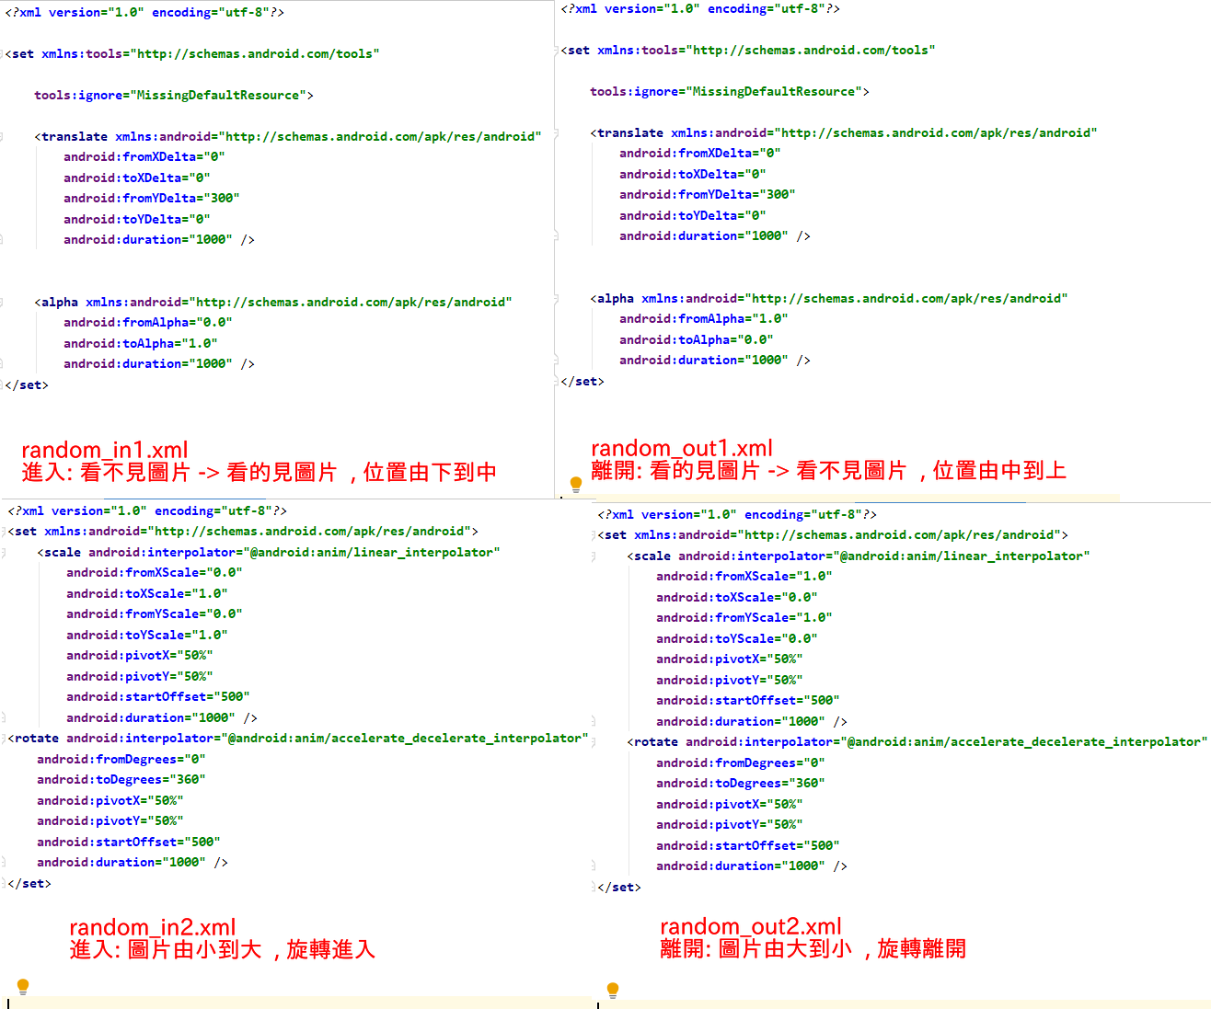(限網頁版觀看gif)

MainActivity.java(只有改這個，layout檔&string檔都沒改)

**package** com.app.myapplication;  
  
**import** android.graphics.Color;  
**import** android.support.v7.app.AppCompatActivity;  
**import** android.os.Bundle;  
**import** android.view.View;  
**import** android.view.ViewGroup;  
**import** android.view.animation.AnimationUtils;  
**import** android.widget.AdapterView;  
**import** android.widget.GridView;  
**import** android.widget.ImageSwitcher;  
**import** android.widget.ImageView;  
**import** android.widget.ViewSwitcher;  
  
**public class** MainActivity **extends** AppCompatActivity **implements** ViewSwitcher.ViewFactory {  
  
 **private** GridView **mGridView**;  
 **private** ImageSwitcher **mImgSwitcher**;  
  
 *// 這個縮圖陣列是App專案的影像資源ID* Integer[] **miThumbImgArr** = {  
 R.drawable.***img01th***, R.drawable.***img02th***, R.drawable.***img03th***,  
 R.drawable.***img04th***, R.drawable.***img05th***, R.drawable.***img06th***,  
 R.drawable.***img07th***, R.drawable.***img08th***};  
  
 *// 這個圖片陣列是App專案的影像資源ID* **private** Integer[] **miImgArr** = {  
 R.drawable.***img01***, R.drawable.***img02***, R.drawable.***img03***,  
 R.drawable.***img04***, R.drawable.***img05***, R.drawable.***img06***,  
 R.drawable.***img07***, R.drawable.***img08***};  
  
  
 @Override  
 **protected void** onCreate(Bundle savedInstanceState) {  
 **super**.onCreate(savedInstanceState);  
 setContentView(R.layout.***activity_main***);  
  
 *// 建立一個ImageAdapter型態的物件* ImageAdapter imgAdap = **new** ImageAdapter(getApplicationContext(), **miThumbImgArr**);  
  
 **mGridView** = findViewById(R.id.***gridView***);  
 **mGridView**.setAdapter(imgAdap);  
  
 *// 設定GridView物件的OnItemClickListener* **mGridView**.setOnItemClickListener(**gridViewOnItemClick**);  
  
 **mImgSwitcher** = findViewById(R.id.***imgSwitcher***);  
  
 **mImgSwitcher**.setFactory(**this**); *// 主程式類別必須implements  
 // ViewSwitcher.ViewFactory* }  
  
 **private** AdapterView.OnItemClickListener **gridViewOnItemClick** = **new** AdapterView.OnItemClickListener() {  
 @Override  
 **public void** onItemClick(AdapterView<?> adapterView, View view, **int** i, **long** l) {  
 **int** r = (**int**)(Math.*random*()*2+1);  
 **switch** (r) {  
 **case** 1:  
 **mImgSwitcher**.setInAnimation(AnimationUtils.*loadAnimation*(getApplicationContext(),  
 R.anim.***random_in1***));  
 **mImgSwitcher**.setOutAnimation(AnimationUtils.*loadAnimation*(getApplicationContext(),  
 R.anim.***random_out1***));  
 **break**;  
 **case** 2:  
 **mImgSwitcher**.setInAnimation(AnimationUtils.*loadAnimation*(getApplicationContext(),  
 R.anim.***random_in2***));  
 **mImgSwitcher**.setOutAnimation(AnimationUtils.*loadAnimation*(getApplicationContext(),  
 R.anim.***random_out2***));  
 **break**;  
 }  
 **mImgSwitcher**.setImageResource(**miImgArr**[i]);  
 }  
 };  
  
 @Override  
 **public** View makeView() {  
 ImageView v = **new** ImageView(**this**);  
 v.setBackgroundColor(0xFF000000);  
 v.setScaleType(ImageView.ScaleType.***FIT_CENTER***);  
 v.setLayoutParams(**new** ImageSwitcher.LayoutParams(  
 ViewGroup.LayoutParams.***MATCH_PARENT***,  
 ViewGroup.LayoutParams.***MATCH_PARENT***));  
 v.setBackgroundColor(Color.***WHITE***);  
 **return** v;  
 }  
}

random_in1.xml

*<?***xml version="1.0" encoding="utf-8"***?>*<**set xmlns:tools="http://schemas.android.com/tools"  
  
 tools:ignore="MissingDefaultResource"**>  
  
 <**translate xmlns:android="http://schemas.android.com/apk/res/android"  
 android:fromXDelta="0"  
 android:toXDelta="0"  
 android:fromYDelta="300"  
 android:toYDelta="0"  
 android:duration="1000"** />  
  
  
 <**alpha xmlns:android="http://schemas.android.com/apk/res/android"  
 android:fromAlpha="0.0"  
 android:toAlpha="1.0"  
 android:duration="1000"** />  
</**set**>

random_out1.xml

*<?***xml version="1.0" encoding="utf-8"***?>*<**set xmlns:tools="http://schemas.android.com/tools"  
  
 tools:ignore="MissingDefaultResource"**>  
  
 <**translate xmlns:android="http://schemas.android.com/apk/res/android"  
 android:fromXDelta="0"  
 android:toXDelta="0"  
 android:fromYDelta="300"  
 android:toYDelta="0"  
 android:duration="1000"** />  
  
  
 <**alpha xmlns:android="http://schemas.android.com/apk/res/android"  
 android:fromAlpha="1.0"  
 android:toAlpha="0.0"  
 android:duration="1000"** />  
</**set**>

random_in2.xml

*<?***xml version="1.0" encoding="utf-8"***?>*<**set xmlns:android="http://schemas.android.com/apk/res/android"**>  
 <**scale android:interpolator="@android:anim/linear_interpolator"  
 android:fromXScale="0.0"  
 android:toXScale="1.0"  
 android:fromYScale="0.0"  
 android:toYScale="1.0"  
 android:pivotX="50%"  
 android:pivotY="50%"  
 android:startOffset="500"  
 android:duration="1000"** />  
<**rotate android:interpolator="@android:anim/accelerate_decelerate_interpolator"  
 android:fromDegrees="0"  
 android:toDegrees="360"  
 android:pivotX="50%"  
 android:pivotY="50%"  
 android:startOffset="500"  
 android:duration="1000"** />  
</**set**>

random_out2.xml

*<?***xml version="1.0" encoding="utf-8"***?>*<**set xmlns:android="http://schemas.android.com/apk/res/android"**>  
 <**scale android:interpolator="@android:anim/linear_interpolator"  
 android:fromXScale="1.0"  
 android:toXScale="0.0"  
 android:fromYScale="1.0"  
 android:toYScale="0.0"  
 android:pivotX="50%"  
 android:pivotY="50%"  
 android:startOffset="500"  
 android:duration="1000"** />  
 <**rotate android:interpolator="@android:anim/accelerate_decelerate_interpolator"  
 android:fromDegrees="0"  
 android:toDegrees="360"  
 android:pivotX="50%"  
 android:pivotY="50%"  
 android:startOffset="500"  
 android:duration="1000"** />  
</**set**>